PE03 Result screenshot

Link for my Git Hub

<https://github.com/Jheyneopc/CS624-MobileApp.git>

Part 1

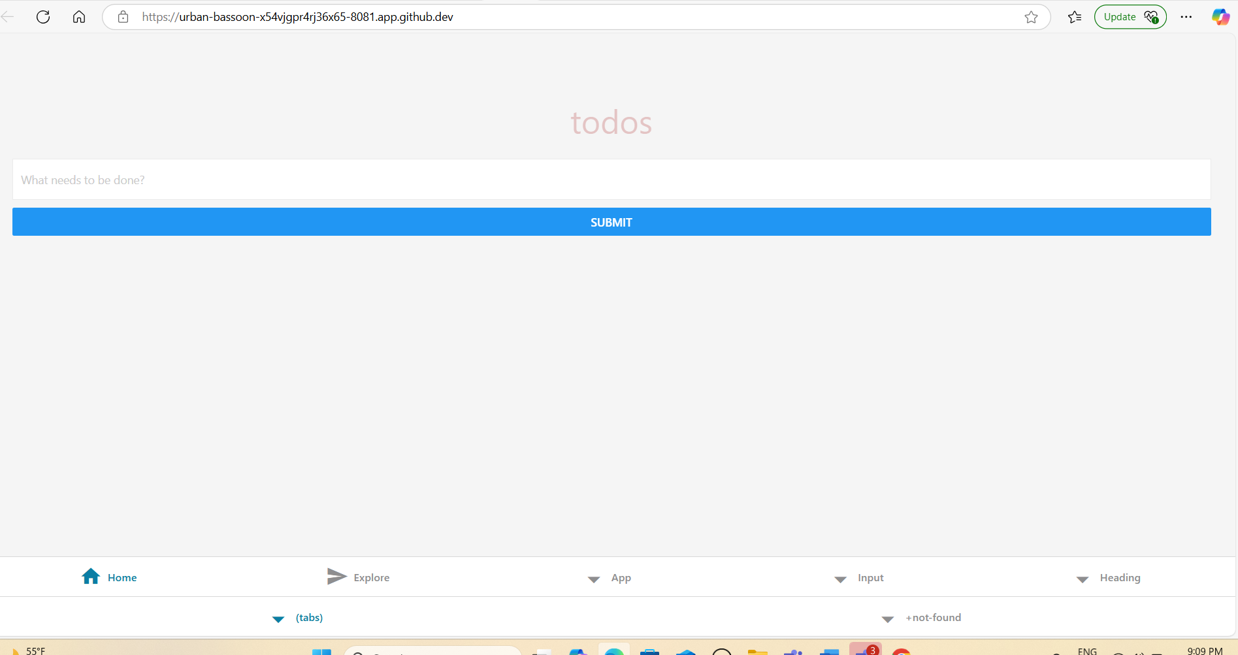

Part 2

